FOGRA CERTIFICATION
FOGRA is a certified standard to ensure consistent quality of print output for proofing applications. It reduces waste at all stages of the proof printing workflow, we provide a range of FOGRA certified media.
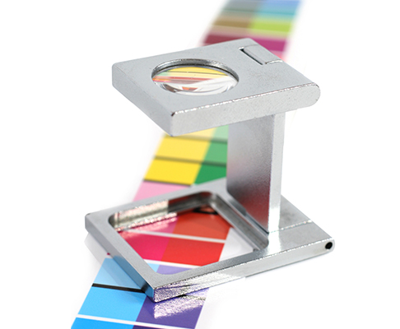

FOGRA certification - the guarantee behind the certification
As the digital print industry continues to progress the development of new technologies and processes, it is essential that all components of digital output keeps pace with the rapid rate of change; whilst instilling confidence in the materials and substrates being utilised. Essentially, customer retention is achieved through consistency in the products and services you provide them and the output, as this reflects upon you - the supplier. Now with ArtSystems FOGRA certified proofing media you can ensure colour accurate proofing in compliance with international colour standards.

Who are FOGRA?
Based in Munich, Germany, FOGRA is an organisation of international experts focused in the research and developments of colour management and testing practices, standardisation, control products and workflow processes.

The range
The satin proofing media range is available in sizes from 17 to 42 inches wide and 200gsm to 255gsm thick (FOGRA certification 23219-3 and FOGRA certification number 23219-1) respectively and a range of gloss proofing media is also available in sizes from 17 to 42 inches wide and also 200gsm to 255gsm thick (FOGRA certification 23219-2 and FOGRA certification number 23219-4). All are certified to ISO 12647-4-2008 (graphics technology - process control for the production of half-tone colour separations, proof and production prints - part 7: off press proofing process working directly from digital data); and ISO 8254-1 specifications which are ideal for contract proofing and data to day proofing requirements.

Standardisation
The principle of "FOGRA-certification" is standardisation, which means ArtSystems proofing media consistently meets a very stringent testing criteria determined by the international Standards Organisation (ISO) and FOGRA at all critical control points. This is the guarantee for unified colour coordinates for proofing substrates.
Download testing criteria and tolerance information

The benefits
The most demanding customers will expect nothing less than certified substrates for their proof printing, therefore ArtSystems FOGRA certified proofing media is your licence to trade in these lucrative and prestigious market-place, opening up new sales opportunities.
As more businesses become more cost conscious, the advantages of reliable proofing output becomes more of an important selling factor, lower media and ink usage up to the contract sign off, less energy and materials used in the workflow and efficient allocations of resources all add up to cost savings that go direct to the bottom line.
Download more information about the FOGRA organisation

